Processing Technologies for the Forest & Biobased Products Industries

PTF BPI 2026


Program & Agenda
November 9-11, 2026
St. Simons Island, GA

Table of Contents

Thank You Sponsors! 4
Preface - The 11th PTF BPI International Conference 5
UT School of Natural Resources ‘Data Science Institute’ 6
Venue Information 8
Program 9
Monday, November 9, 2026 9
Conference Workshop: Machine Learning for Discovering Unknown Sources of Variation* - Lanier II 9
Conference Workshop: Fundamentals of Adhesives* - Lanier III 9
Golf Outing* - 11:00 am at Heritage Oaks Golf Club 9
Tuesday, November 10, 2026 – Lanier Ball Room 9
Industry Showcase Keynotes – Lanier Ball Room 9
Institute and Center Highlights – Lanier Ball Room 10
AI and Machine Learning – Lanier Ball Room 10
AI Round Table – Lanier Ballroom – Lanier Ball Room 11
Applying Innovation – Lanier Ball Room 11
Wednesday, November 11th – Concurrent Sessions 13
Technical Session I: ‘Current Events’ – Lanier I 13
Technical Session II: ‘Unlocking the Value of Wood Extractives’ – Lanier III 13
Technical Session III: ‘Innovations in Nondestructive Testing and Evaluation’ – Lanier II 14
Technical Session IV: ‘Advanced Characterization and Imaging Technologies’ – Lanier I 14
Technical Session V: Machine Learning Applications – LAnier II 15
Technical Session VI: Optimization of Value-Added Products – Lanier III 15
PTF BPI 2026 Committees 16
Notes 19
Academic Endorsements 21

Thank You Sponsors!
Gold ‘Signature’ Sponsor


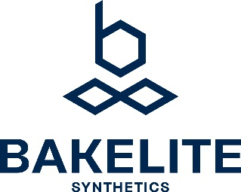

Gold

Silver




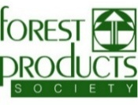
Bronze





Preface - The 11th PTF BPI International Conference
‘Advancing Innovation Applications in AI for Resilience
in a Circular Economy’

PTF BPI 2026 brings industry and academia together to discuss AI, innovation, and applied technologies. This year’s event is hosted by The University of Tennessee, School of Natural Resources, Data Science Institute, https://agdatascience.tennessee.edu/.
This unique conference brings industry leaders, applied industrial innovators, and academic scholars together at the beautiful venue of St. Simons Island, GA. Participants share the latest innovation and applied research ideas for direct applications in the forest and biobased products industries. This conference provides a unique forum for technical and general managers, product development engineers, process engineers, scientists, academicians, and students interested in applied innovation.
Thank You for Joining Us!
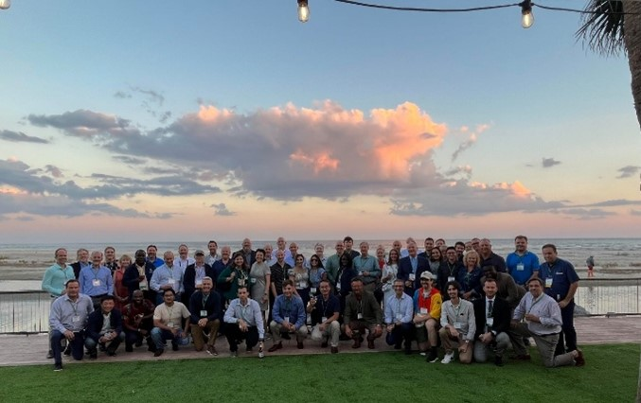
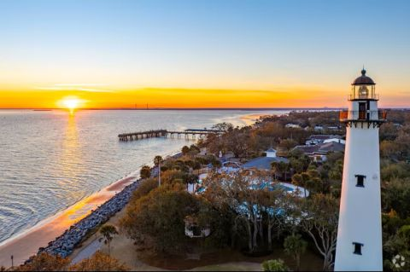

UT School of Natural Resources ‘Data Science Institute’
The PTF BPI 2026 Conference is hosted and sponsored by the University of Tennessee (UT), School of Natural Resources (SNR), Data Science Institute. This year’s conference is being held in conjunction with the Institute’s annual fall conference for its industry members, reflecting the Institute’s commitment to advancing data science, machine learning, and artificial intelligence (AI) in industry.
The mission of the UT SNR Data Science Institute is to advance education and research in data science, machine learning, and AI, with a focus on practical applications that deliver measurable value to companies.
The Institute helps companies learn, adapt, and effectively implement emerging data science, machine learning, and AI technologies to optimize processes, improve operational efficiency, and reduce costs. By providing access to current technologies, applied research, specialized expertise, and educational opportunities, the Institute serves as an extension of a company’s innovation group. This collaborative approach helps companies evaluate new technologies, address complex operational challenges, and translate analytical insights into practical solutions and measurable business outcomes.
Value Proposition for Members
The value proposition of the UT SNR Data Science Institute is to drive sustainable company valuation growth by preparing the workforce to effectively use data science, machine learning, and artificial intelligence (AI).
The effective application of these technologies can help companies reduce operational risk, improve productivity, and increase profitability without requiring proportional increases in capital investment or operating costs. By enabling companies to make better-informed decisions, identify emerging risks, and optimize operational performance, data science, machine learning, and AI can support revenue growth and stronger profit margins.

A central component of this strategy is workforce readiness. Preparing employees to use modern analytical tools and correctly interpret analytical results enables them to identify previously unknown sources of process variation, uncover opportunities for improvement, and implement data-driven solutions. Reducing process variation can improve product quality, increase production efficiency, reduce waste and operating costs, and strengthen overall competitiveness.
Through industry-focused education, applied research, and collaboration, the Institute helps member companies develop the analytical capabilities needed to translate technological advances into measurable business results and long-term, sustainable valuation growth.
Our Current Members



Our Current Executive Board
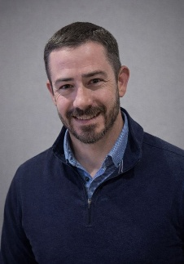 |  | 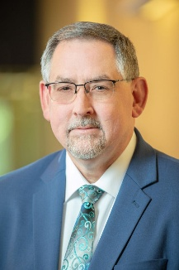 |  | 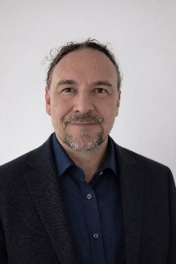
Brandon Higgins  Dir. Optimization & Technology  Roseburg Forest Prod. | Alex Scott  Process Engineering Manager  Louisiana-Pacific Corp. | Walker Campbell  Director of Quality  Huber Engineered Woods | Valentin Kurz  Mgr.: Data, Analytics, AI & Reporting  West Fraser Timber Co. | Teja Schubert  Director Automation & Controls  West Fraser Timber Co.
 |  |  | Shared Board Position

Venue Information

The King and Prince Beach & Golf Resort
201 Arnold Road, St. Simons Island, GA 31522
912-638-3631 | www.kingandprince.com
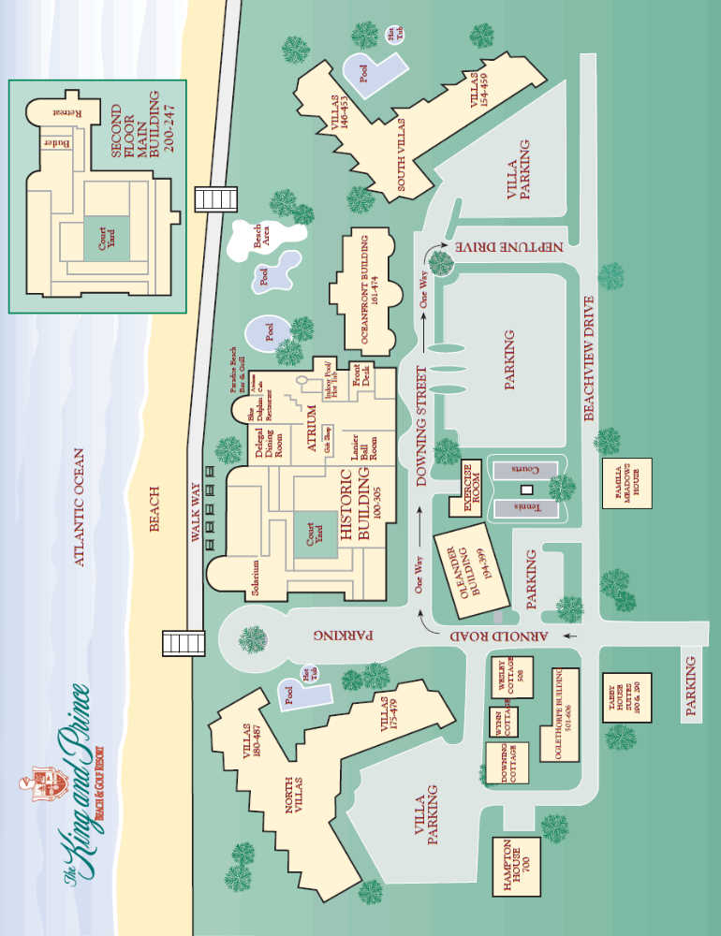

Program

Monday, November 9, 2026
1:00 PM – 5:00 PM

Conference Workshop: Machine Learning for Discovering Unknown Sources of Variation* - Lanier II
Timothy Young, PhD and Johnson Jeeva | University of Tennessee, School of Natural Resources, Data Science Institute​
1:00 PM – 5:00 PM

Conference Workshop: Fundamentals of Adhesives* - Lanier III
Robert Breyer, PhD | Bakelite Synthetics
11:00 AM – 3:30 PM

Golf Outing* - 11:00 am at Heritage Oaks Golf Club
‘Heritage Oaks Golf Club’ - 126 Clipper Bay Rd, Brunswick, GA 31523-8922
*Additional Registration is Required
1:00 PM – 6:00 PM: (Registration Desk Open)

Tuesday, November 10, 2026 – Lanier Ball Room
7:00 AM | Breakfast (Delegal Room) – Registration & Exhibit Hall Open
8:10 AM | Opening Remarks, Recognition of Sponsors, and Welcome

Industry Showcase Keynotes – Lanier Ball Room
8:30 AM | Mike Reardon  Director – Roseburg Forest Products  ‘Innovation and Change in the Composite Panel Business’ | 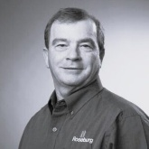
9:00 AM | Dr. Sudip Chowdhury  Vice President of Research and Technology - Arclin Inc. ‘Chemistry, Manufacturing, and Data Intelligence: The New  Engine of Value-Driven Innovation’ | 
9:30 AM | Matt Swinnie  Vice President of Operations – Arauco North America (NA)  Diego Tuleski  Director of IT Global Wood Business – Arauco NA  ‘Using Innovation and AI for Business Success at Arauco NA’ |   
10:00 – 10:30 AM | Coffee Break with Exhibitors

Institute and Center Highlights – Lanier Ball Room
10:30 AM | Valentin Kurz  Manager: Data Analytics, AI & Reporting - West Fraser  ‘West Fraser Remote Operations Center (ROC)’ | 
11:00 AM | Dr. Soledad Peresin  Director of Wood Design and Utilization - Clemson University  ‘Overview of the Wood Utilization & Design Institute (WU+D) & Regional Forestry Economic Development Model - Forest Products Innovation Corridor’ | 
11:30 AM  12:00 PM | Dr. Brian Via  Director of the School of Packaging - Michigan State University  ‘An Overview of MSU School of Packaging’  Lunch and Exhibit Hall Open | 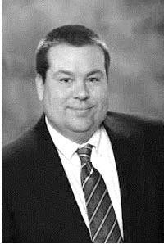

AI and Machine Learning – Lanier Ball Room
12:45 PM | Dr. Mikhail Golovnya  Senior Advisory Data Scientist – Minitab  ‘Demystifying AI: Behind Smoke and Mirrors’ | 
1:15 PM | Michael Malmberg  Senior Director Global Commercial and Solutions – Hexion Inc.  ‘Hexion x Smartech – Advanced Systems to Significantly Lower  Costs in the Current Tough Market | 
1:35 PM | Daniel Fortune  Manager of Global Growth Analytics - Hexion Inc.  ‘Machine Learning for Identifying Sources of Variation in  Continuous Processes’ | 
1:55 PM | Alisa Hunt-Lowery  Senior Systems Engineer - JMP Statistical Discovery, LLC  and  Bill Worley  Principal Systems Engineer - JMP Statistical Discovery, LLC  ‘JMP Applications for Industry’ | 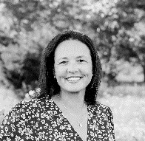  

AI Round Table – Lanier Ballroom – Lanier Ball Room
2:15 – 2:40 PM  2:40 – 3:00 PM | Brian Richmond - Vice President AI Sales, Smartech  Dr. Mikhail Golovnya - Senior Advisory Data Scientist – Minitab  Michael Malmberg - Senior Dir. Global Commercial Solutions – Hexion Inc.  Bill Worley - Principal Systems Engineer - JMP Statistical Discovery, LLC\  Coffee Break with Exhibitors

Applying Innovation – Lanier Ball Room
3:00 PM  3:20 PM | Collin Burruss  Senior Sales Engineer - iba America, LLC  ‘From Production Data to AI: Building the Foundation for Intelligent Forest Products Manufacturing’  Dr. Robert Breyer  Principal Scientist - Bakelite Corporation  ‘The Average Looks Fine… Until You Meet Variability’ |  |   
3:40 PM  4:00 PM  4:20 PM | Brandon Higgins  Director Optimization & Technology - Roseburg Forest Products  ‘Why Lab-based Research Doesn’t Always Work in Manufacturing Processes’  Dr. Chip Frazier  Wood-Based Composites Center - Virginia Tech  ‘Formaldehyde-Protected Lignin, the Unfolding Irony’  Dr. Siqun Wang  Center for Renewable Carbon - University of Tennessee  ‘Development of Fire-Resilient Lignin Foams for the Building Industry’ |  | 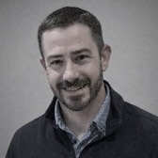  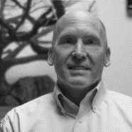  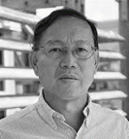
4:40 PM  5:00 PM | Dr. Rubin Shmulsky  Department of Sustainable Bioproducts - Mississippi State Univ.  ‘Energy Absorbing Glulam for the U.S. Defense Infrastructure’  Lorne Fardy  VP Product Development - Kadant Carmanah Design  ‘Improving OSB Stranding Performance with Real-Time Vision Technology’ |  | 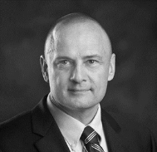  
5:20 – 6:00 | Exhibit Hall Open
5:00 - 6:30 | Cocktails by the Ocean
6:30 PM | Banquet Dinner

Gold ‘Signature’ Sponsor
The Willamette Valley Company, an Arclin Brand, is a leading-edge, multinational corporation that manufactures a wide variety of custom products throughout the United States, Europe, Canada, Asia, Australia, and South America.

While our roots are in the wood products industry and go back to our inception in 1952, our expertise and solutions now encompass:
- Innovative Materials for Transportation
- Original Equipment Manufacturing
- Telecom Industries
- Custom Robotics for Unique Applications


Wednesday, November 11th – Concurrent Sessions
7:30 - 8:30 AM | Breakfast (Delegal Room) and Exhibitor Hall Open

Technical Session I: ‘Current Events’ – Lanier I
 | Moderator: Fred Kurpiel
8:30 – 10:00 AM | Harold Arnold  President - Fram Renewable Fuels, LLC  ‘The Wood Pellet Industry: Analysis of Present Markets and Future Opportunities’
Brandon Higgins
Director Optimization & Technology - Roseburg Forest Products
‘Current Events at Roseburg Startups’

Walker Campbell
Director of Quality - Huber Engineered Woods, LLC
‘Current Events at HEW Startups’

Devon Dartnell
Director of Forest Services, Utilization & Marketing - Georgia Forestry Commission
‘The Georgia Governors’ Forestry Task Force and the Georgia Forestry Innovation Initiative’

Technical Session II: ‘Unlocking the Value of Wood Extractives’ – Lanier III
8:30 – 10:00 AM | Moderator: Dr. Siqun Wang  Dr. Gwendolyn D. Boyd-Shields  Department of Sustainable Bioproducts, Mississippi State University  ‘Next-Generation Sustainable Wood Protection: Citric Acid-Crosslinked Chitosan as a Renewable Platform for Enhanced Durability and Moisture Resistance’
Abigael Laisa
Department of Sustainable Bioproducts, Mississippi State University
‘Leaching Resistance of Wood Treated with Laboratory-Synthesized and Commercial Chitosan Oligomers’
Daniel Owusu Sekyere
Wood Utilization + Design Institute, Clemson University
‘Composition-Property Relationships in Cellulose Nanofiber-Chitosan Aerogels for Water Remediation’

Diego Cuartas-Marulanda
Wood Utilization and Design Institute, Clemson University
‘Understanding the Fundamental Influence of Wood Extractives on Wood Adhesion’

Technical Session III: ‘Innovations in Nondestructive Testing and Evaluation’ – Lanier II
8:30 – 10:00 AM | Moderator: Dr. Brian Via  Dalila Belaidi  Department of Sustainable Bioproducts, Mississippi State University  ‘Nondestructive Evaluation and Finite Element Prediction of Bending Performance in Red Maple Laminated Veneer Lumber’  Manal Bouchlouch  Department of Sustainable Bioproducts, Mississippi State University  ‘Stress-wave Evaluation of Glued-Laminated Timber for Stiffness Characterization and Delamination Detection’  Elnaz Janghorban  Department of Sustainable Bioproducts, Mississippi State University  ‘Nondestructive Evaluation of Used Timber Mates by Builder’s-Level Load-Deflection Testing’  Tilak Neupane  Department of Sustainable Bioproducts, Mississippi State University  ‘A Deep Learning Based Fusion Framework of Handcrafted Texture and CNN Features for Wood Chip Moisture Content Estimation’
Break: 10:00 – 10:30 AM | Exhibitor Hall Open

Technical Session IV: ‘Advanced Characterization and Imaging Technologies’ – Lanier I
10:30 AM – 12:00 PM | Moderator: Dr. Don Hodges  Dr. Anton Astner  Oak Ridge National Laboratory (ORNL), Oak Ridge, TN  ‘Small-angle Neutron Scattering-derived Structural Descriptions for Data-driven Optimization of Lignocellulosic Biomass Pretreatment’  Geo Francis  Wood K plus – Competence Center for Wood Composites & Wood Chemistry, Linz Austria  ‘Towards Reliable Wood Log Re-identification: An Explainable AI Approach’  Stefan Kain  University of Applied Sciences Salzburg, Kuchl Austria  ‘From Natural Fibre Composites to 4D Printing Processing, Mechanical Properties and Moisture-Response Behavior’  Aadarsha Lamichhane  Department of Sustainable Bioproducts, Mississippi State University  ‘Geometry-Driven Cellular Beams from Corrugated Wood-Strand Panels’

Technical Session V: Machine Learning Applications – LAnier II
10:30 AM – 12:00 PM | Moderator: Dr. Timothy Young  Dr. Robert Breyer  Bakelite Synthetics  ‘Interrogating the Data until it Confesses: The Art of P Hacking’
Dr. Mikhail Golovnya
Minitab
‘Machine Learning Applications in Minitab’

Kirk Copley
Huber Engineered Woods, LLC
‘Machine Learning Applications in R and Python’

Johnson Jeeva
University of Tennessee and West Fraser
‘Machine Learning using Python with Applications in Minitab and JMP’

Technical Session VI: Optimization of Value-Added Products – Lanier III
10:30 AM – 12:00 PM | Moderator: Dr. Layla Khademibami  Andrew Porter  Wood Utilization and Design Institute, Clemson University  ‘Optimization of High-Shear Mechanical Disintegration for the Production and Characterization of Colloidal Particles’  Arun Kuttoor Vasudevan  Department of Sustainable Bioproducts, Mississippi State University  ‘Curved Corrugated Panels: Geometry-Driven Core Optimization of Engineered Wood Beams’  Harika Undadi  Department of Sustainable Bioproducts, Mississippi State University  ‘Adhesive Compatibility with Thermally Modified Wood’
Duber Garces
Wood Utilization + Design Institute, Clemson University
‘Evaluation of Hydrogel Beads as Slow-Release Fertilizer Systems for Pecan Seedlings’

Nauman Ahmed
Department of Sustainable Bioproducts, Mississippi State University
‘From Laboratory Promise to Practical Bio-Based Wood Protection’
12:00 PM | Conference Adjourns

PTF BPI 2026 Committees

Conference Chairs
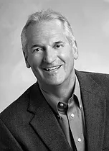  Dr. Timothy M. Young  The University of Tennessee  tmyoung1@utk.edu  +01.865.356.1151 |   Dr. Alexander Petutschnigg  Salzburg University of Applied Sciences  alexander.petutschnigg@fh-salzburg.ac.at  +43.50.2211.2011
Organizing Chairs
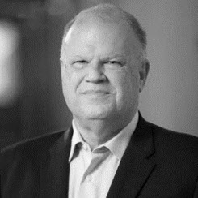  Dr. Terry Liles  Consultant, retired from Huber Engineered Woods, LLC  wtliles@hotmail.com  +01.706.338.6359 | 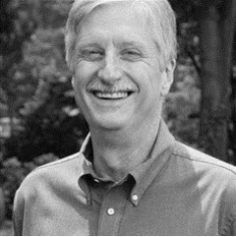  Dr. Don Hodges  The University of Tennessee  dhodges2@utk.edu  +01.865.974.2706
Scientific Chairs
Dr. Brian Via  Michigan State University  brianvia@auburn.edu  +01.334.844.1088 |   Dr. Robert Breyer  Bakelite  bob.breyer@bakelite.com  +01.770.593.6879
Scientific Committee
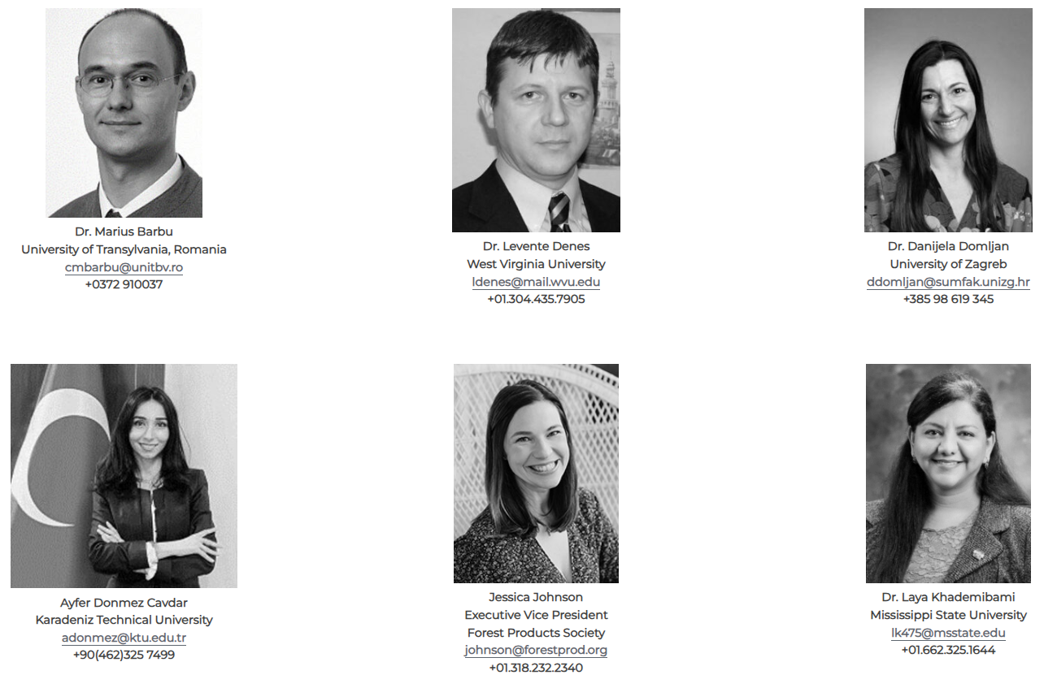
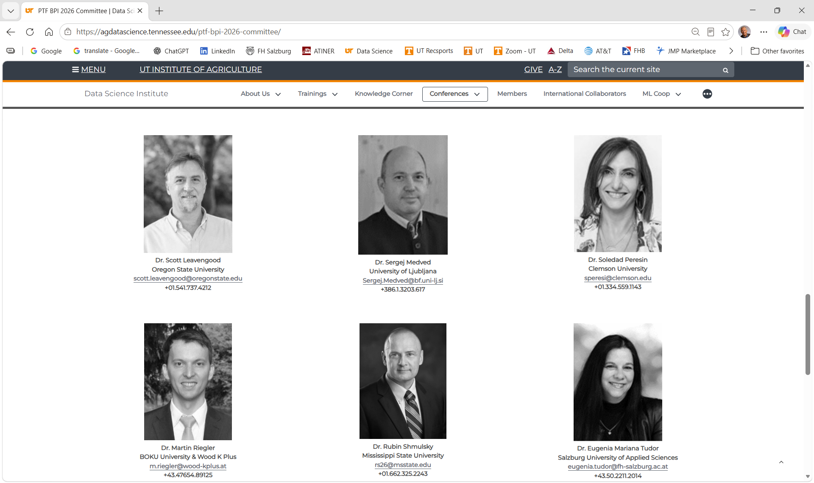
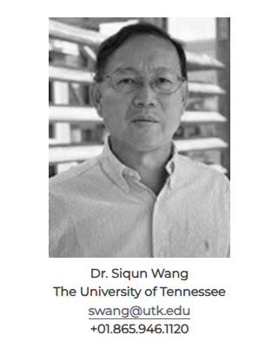

Notes

____________________________________________________________________________________________________________________________________________________________________________________________________________________________________________________________________________________________________________________________________________________________________________________________________________________________________________________________________________________________________________________________________________________________________________________________________________________________________________________________________________________________________________________________________________________________________________________________________________________________________________________________________________________________________________________________________________________________________________________________________________________________________________________________________________________________________________________________________________________________________________________________________________________________________________________________________________________________________________________________________________________________________________________________________________________________________________________________
Notes

__________________________________________________________________________________________________________________________________________________________________________________________________________________________________________________________________________________________________________________________________________________________________________________________________________________________________________________________________________________________________________________________________________________________________________________________________________________________________________________________________________________________________________________________________________________________________________________________________________________________________________________________________________________________________________________________________________________________________________________________________________________________________________________________________________________________________________________________________________________________________________________________________________________________________________________________________________________________________________________________________________________________________________________________________________________________________________________________________________________________________________________________________________

Academic Endorsements











